What is Kubernetes?
Kubernetes is a portable, extensible, open-source platform for managing
containerized workloads and services, that facilitates both declarative
configuration and automation. It has a large, rapidly growing ecosystem.
Kubernetes services, support, and tools are widely available.
This page is an overview of Kubernetes.
Kubernetes is a portable, extensible, open-source platform for managing
containerized workloads and services, that facilitates both declarative
configuration and automation. It has a large, rapidly growing ecosystem.
Kubernetes services, support, and tools are widely available.
The name Kubernetes originates from Greek, meaning helmsman or pilot. Google open-sourced the Kubernetes project in 2014. Kubernetes combines over 15 years of Google's experience running production workloads at scale with best-of-breed ideas and practices from the community.
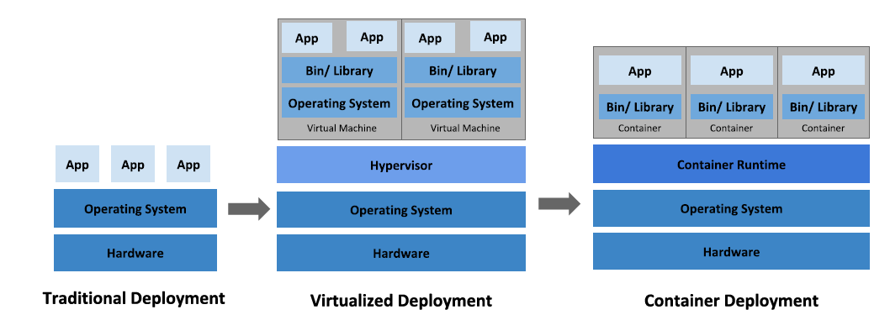

Traditional deployment era: Early on, organizations ran applications on
physical servers. There was no way to define resource boundaries for
applications in a physical server, and this caused resource allocation issues.
For example, if multiple applications run on a physical server, there can be instances where one application would take up most of the resources, and as a result, the other applications would underperform. A solution for this would be to run each application on a different physical server. But this did not scale as resources were underutilized, and it was expensive for organizations to maintain many physical servers.

Virtualized deployment era: As a solution, virtualization was introduced.
It allows you to run multiple Virtual Machines (VMs) on a single physical
server's CPU. Virtualization allows applications to be isolated between VMs
and provides a level of security as the information of one application cannot
be freely accessed by another application.
Virtualization allows better utilization of resources in a physical server and
allows better scalability because an application can be added or updated
easily, reduces hardware costs, and much more. With virtualization you can
present a set of physical resources as a cluster of disposable virtual
machines.
Each VM is a full machine running all the components, including its own operating system, on top of the virtualized hardware.

Container deployment era: Containers are similar to VMs, but they have
relaxed isolation properties to share the Operating System (OS) among the
applications. Therefore, containers are considered lightweight. Similar to a
VM, a container has its own filesystem, share of CPU, memory, process
space, and more. As they are decoupled from the underlying infrastructure,
they are portable across clouds and OS distributions.
Containers have become popular because they provide extra benefits, such
as:
Agile application creation and deployment: increased ease and
efficiency of container image creation compared to VM image use.
Continuous development, integration, and deployment: provides for
reliable and frequent container image build and deployment with quick
and easy rollbacks (due to image immutability).
Dev and Ops separation of concerns: create application container
images at build/release time rather than deployment time, thereby
decoupling applications from infrastructure.
Observability not only surfaces OS-level information and metrics, but
also application health and other signals.
Environmental consistency across development, testing, and
production: Runs the same on a laptop as it does in the cloud.
Cloud and OS distribution portability: Runs on Ubuntu, RHEL, CoreOS,
on-premises, on major public clouds, and anywhere else.
Application-centric management: Raises the level of abstraction from
running an OS on virtual hardware to running an application on an OS
using logical resources.
Loosely coupled, distributed, elastic, liberated micro-services:
applications are broken into smaller, independent pieces and can be
deployed and managed dynamically - not a monolithic stack running on
one big single-purpose machine.
Resource isolation: predictable application performance.
Resource utilization: high efficiency and density.

Why you need Kubernetes and what it can do
Containers are a good way to bundle and run your applications. In a
production environment, you need to manage the containers that run the
applications and ensure that there is no downtime. For example, if a
container goes down, another container needs to start. Wouldn't it be easier
if this behavior was handled by a system?
That's how Kubernetes comes to the rescue! Kubernetes provides you with a
framework to run distributed systems resiliently. It takes care of scaling and
failover for your application, provides deployment patterns, and more. For
example, Kubernetes can easily manage a canary deployment for your
system.
Kubernetes provides you with:
Service discovery and load balancing Kubernetes can expose a
container using the DNS name or using their own IP address. If traffic
to a container is high, Kubernetes is able to load balance and distribute
the network traffic so that the deployment is stable.
Storage orchestration Kubernetes allows you to automatically mount
a storage system of your choice, such as local storages, public cloud
providers, and more.
Automated rollouts and rollbacks You can describe the desired state
for your deployed containers using Kubernetes, and it can change the
actual state to the desired state at a controlled rate. For example, you
can automate Kubernetes to create new containers for your
deployment, remove existing containers and adopt all their resources to
the new container.
Automatic bin packing You provide Kubernetes with a cluster of
nodes that it can use to run containerized tasks. You tell Kubernetes
how much CPU and memory (RAM) each container needs. Kubernetes
can fit containers onto your nodes to make the best use of your
resources.
Self-healing Kubernetes restarts containers that fail, replaces
containers, kills containers that don't respond to your user-defined
health check, and doesn't advertise them to clients until they are ready
to serve.
Secret and configuration management Kubernetes lets you store
and manage sensitive information, such as passwords, OAuth tokens,
and SSH keys. You can deploy and update secrets and application
configuration without rebuilding your container images, and without
exposing secrets in your stack configuration.

What Kubernetes is not
Kubernetes is not a traditional, all-inclusive PaaS (Platform as a Service)
system. Since Kubernetes operates at the container level rather than at the
hardware level, it provides some generally applicable features common to
PaaS offerings, such as deployment, scaling, load balancing, and lets users
integrate their logging, monitoring, and alerting solutions. However,
Kubernetes is not monolithic, and these default solutions are optional and
pluggable. Kubernetes provides the building blocks for building developer
platforms, but preserves user choice and flexibility where it is important.

Kubernetes:
Does not limit the types of applications supported. Kubernetes aims to
support an extremely diverse variety of workloads, including stateless,
stateful, and data-processing workloads. If an application can run in a
container, it should run great on Kubernetes.
Does not deploy source code and does not build your application.
Continuous Integration, Delivery, and Deployment (CI/CD) workflows
are determined by organization cultures and preferences as well as
technical requirements.
Does not provide application-level services, such as middleware (for
example, message buses), data-processing frameworks (for example,
Spark), databases (for example, MySQL), caches, nor cluster storage
systems (for example, Ceph) as built-in services. Such components can
run on Kubernetes, and/or can be accessed by applications running on
Kubernetes through portable mechanisms, such as the Open Service
Broker.
Does not dictate logging, monitoring, or alerting solutions. It provides
some integrations as proof of concept, and mechanisms to collect and
export metrics.
Does not provide nor mandate a configuration language/system (for
example, Jsonnet). It provides a declarative API that may be targeted by
arbitrary forms of declarative specifications.
Does not provide nor adopt any comprehensive machine configuration,
maintenance, management, or self-healing systems.
Additionally, Kubernetes is not a mere orchestration system. In fact, it
eliminates the need for orchestration. The technical definition of
orchestration is execution of a defined workflow: first do A, then B, then
C. In contrast, Kubernetes comprises a set of independent, composable
control processes that continuously drive the current state towards the
provided desired state. It shouldn't matter how you get from A to C.
Centralized control is also not required. This results in a system that is
easier to use and more powerful, robust, resilient, and extensible.

Kubernetes Components

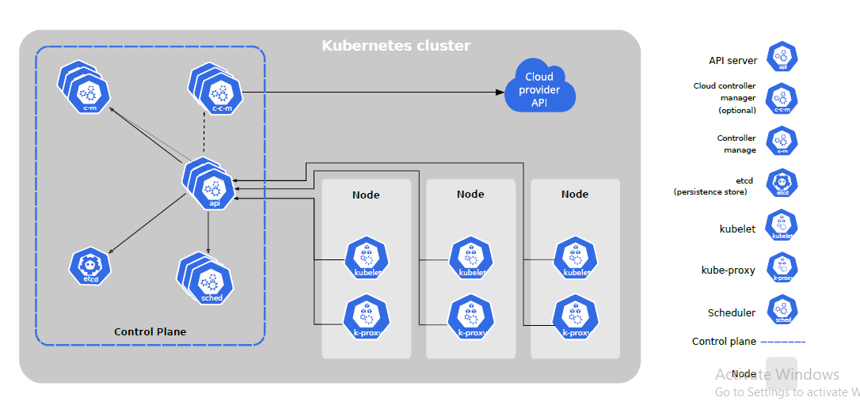

Control Plane Components
The control plane's components make global decisions about the cluster (for
example, scheduling), as well as detecting and responding to cluster events
(for example, starting up a new pod when a deployment's replicas field is
unsatisfied).
Control plane components can be run on any machine in the cluster.
However, for simplicity, set up scripts typically start all control plane
components on the same machine, and do not run user containers on this
machine. See Building High-Availability Clusters for an example multimaster-
VM setup.

kube-apiserver
The API server is a component of the Kubernetes control plane that exposes
the Kubernetes API. The API server is the front end for the Kubernetes
control plane.
The main implementation of a Kubernetes API server is kube-apiserver.
kube-apiserver is designed to scale horizontallyâ€”that is, it scales by
deploying more instances. You can run several instances of kube-apiserver
and balance traffic between those instances.
etcd
Consistent and highly-available key value store used as Kubernetes' backing
store for all cluster data.
If your Kubernetes cluster uses etcd as its backing store, make sure you
have a back up plan for those data.
kube-scheduler
Control plane component that watches for newly created Pods with no
assigned node, and selects a node for them to run on.
Factors taken into account for scheduling decisions include: individual and
collective resource requirements, hardware/software/policy constraints,
affinity and anti-affinity specifications, data locality, inter-workload
interference, and deadlines.
kube-controller-manager
Control Plane component that runs controller processes.
Logically, each controller is a separate process, but to reduce complexity,
they are all compiled into a single binary and run in a single process.
These controllers include:
Node controller: Responsible for noticing and responding when nodes
go down.
•
Replication controller: Responsible for maintaining the correct number
of pods for every replication controller object in the system.
Endpoints controller: Populates the Endpoints object (that is, joins
Services & Pods).
Service Account & Token controllers: Create default accounts and API
access tokens for new namespaces.
cloud-controller-manager
A Kubernetes control plane component that embeds cloud-specific control
logic. The cloud controller manager lets you link your cluster into your cloud
provider's API, and separates out the components that interact with that
cloud platform from components that just interact with your cluster.
The cloud-controller-manager only runs controllers that are specific to your
cloud provider. If you are running Kubernetes on your own premises, or in a
learning environment inside your own PC, the cluster does not have a cloud
controller manager.
As with the kube-controller-manager, the cloud-controller-manager
combines several logically independent control loops into a single binary
that you run as a single process. You can scale horizontally (run more than
one copy) to improve performance or to help tolerate failures.
The following controllers can have cloud provider dependencies:
Node controller: For checking the cloud provider to determine if a node
has been deleted in the cloud after it stops responding
Route controller: For setting up routes in the underlying cloud
infrastructure
Service controller: For creating, updating and deleting cloud provider
load balancers

Nodes
Kubernetes runs your workload by placing containers into Pods to run on
Nodes. A node may be a virtual or physical machine, depending on the
cluster. Each node contains the services necessary to run Pods, managed by
the control plane.
Typically you have several nodes in a cluster; in a learning or resourcelimited
environment, you might have just one.
The components on a node include the kubelet, a container runtime, and the
kube-proxy.
Node Components
Node components run on every node, maintaining running pods and
providing the Kubernetes runtime environment.
kubelet
An agent that runs on each node in the cluster. It makes sure that containers
are running in a Pod.
The kubelet takes a set of PodSpecs that are provided through various
mechanisms and ensures that the containers described in those PodSpecs
are running and healthy. The kubelet doesn't manage containers which were
not created by Kubernetes.
kube-proxy
kube-proxy is a network proxy that runs on each node in your cluster,
implementing part of the Kubernetes Service concept.
kube-proxy maintains network rules on nodes. These network rules allow
network communication to your Pods from network sessions inside or
outside of your cluster.
kube-proxy uses the operating system packet filtering layer if there is oneand it's available. Otherwise, kube-proxy forwards the traffic itself.

There are two main ways to have Nodes added to the API server:
- The kubelet on a node self-registers to the control plane
- You, or another human user, manually add a Node object (40)
Imperative commands
When using imperative commands, a user operates directly on live objects in
a cluster. The user provides operations to the kubectl command as
arguments or flags.
This is the simplest way to get started or to run a one-off task in a cluster.
Because this technique operates directly on live objects, it provides no
history of previous configurations.
Examples
Run an instance of the nginx container by creating a Deployment object:
kubectl create deployment nginx --image nginx

Kubectl create run path -- image= nginx

Pod yaml file

apiVersion: v1
kind: Pod
metadata:
name: nginx-demo
spec:
containers:
- name: nginx
image: nginx
ports:
- containerPort: 80

apiVersion: v1
kind: Pod
metadata:
name: label-demo
labels:
environment: production
app: nginx
spec:
containers:
- name: nginx
image: nginx: ports:
- containerPort: 80

Namespaces
Kubernetes supports multiple virtual clusters backed by the same physical
cluster. These virtual clusters are called namespaces.

Namespaces provide a scope for names. Names of resources need to be
unique within a namespace, but not across namespaces. Namespaces cannot
be nested inside one another and each Kubernetes resource can only be in
one namespace.

Kubernetes starts with four initial namespaces:

default The default namespace for objects with no other namespace
kube-system The namespace for objects created by the Kubernetes
system
kube-public This namespace is created automatically and is readable
by all users (including those not authenticated). This namespace is
mostly reserved for cluster usage, in case that some resources should
be visible and readable publicly throughout the whole cluster. The
public aspect of this namespace is only a convention, not a
requirement.
kube-node-lease This namespace for the lease objects associated with
each node which improves the performance of the node heartbeats as
the cluster scales.

